Section 24: Other Services

AWS Solution Architect Associate

# 264. CICD Introduction

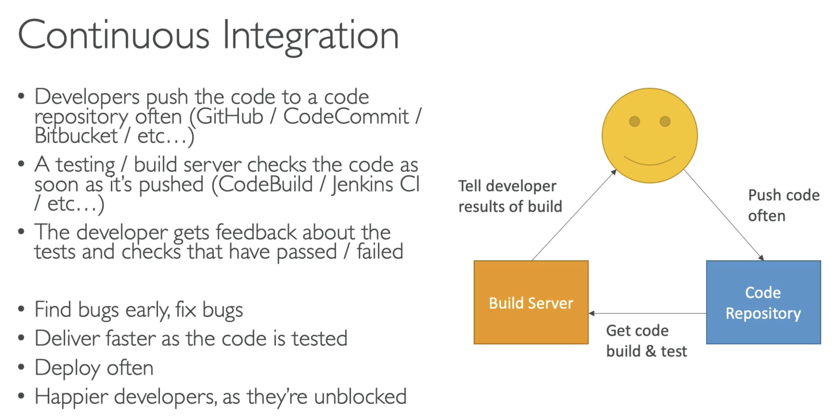

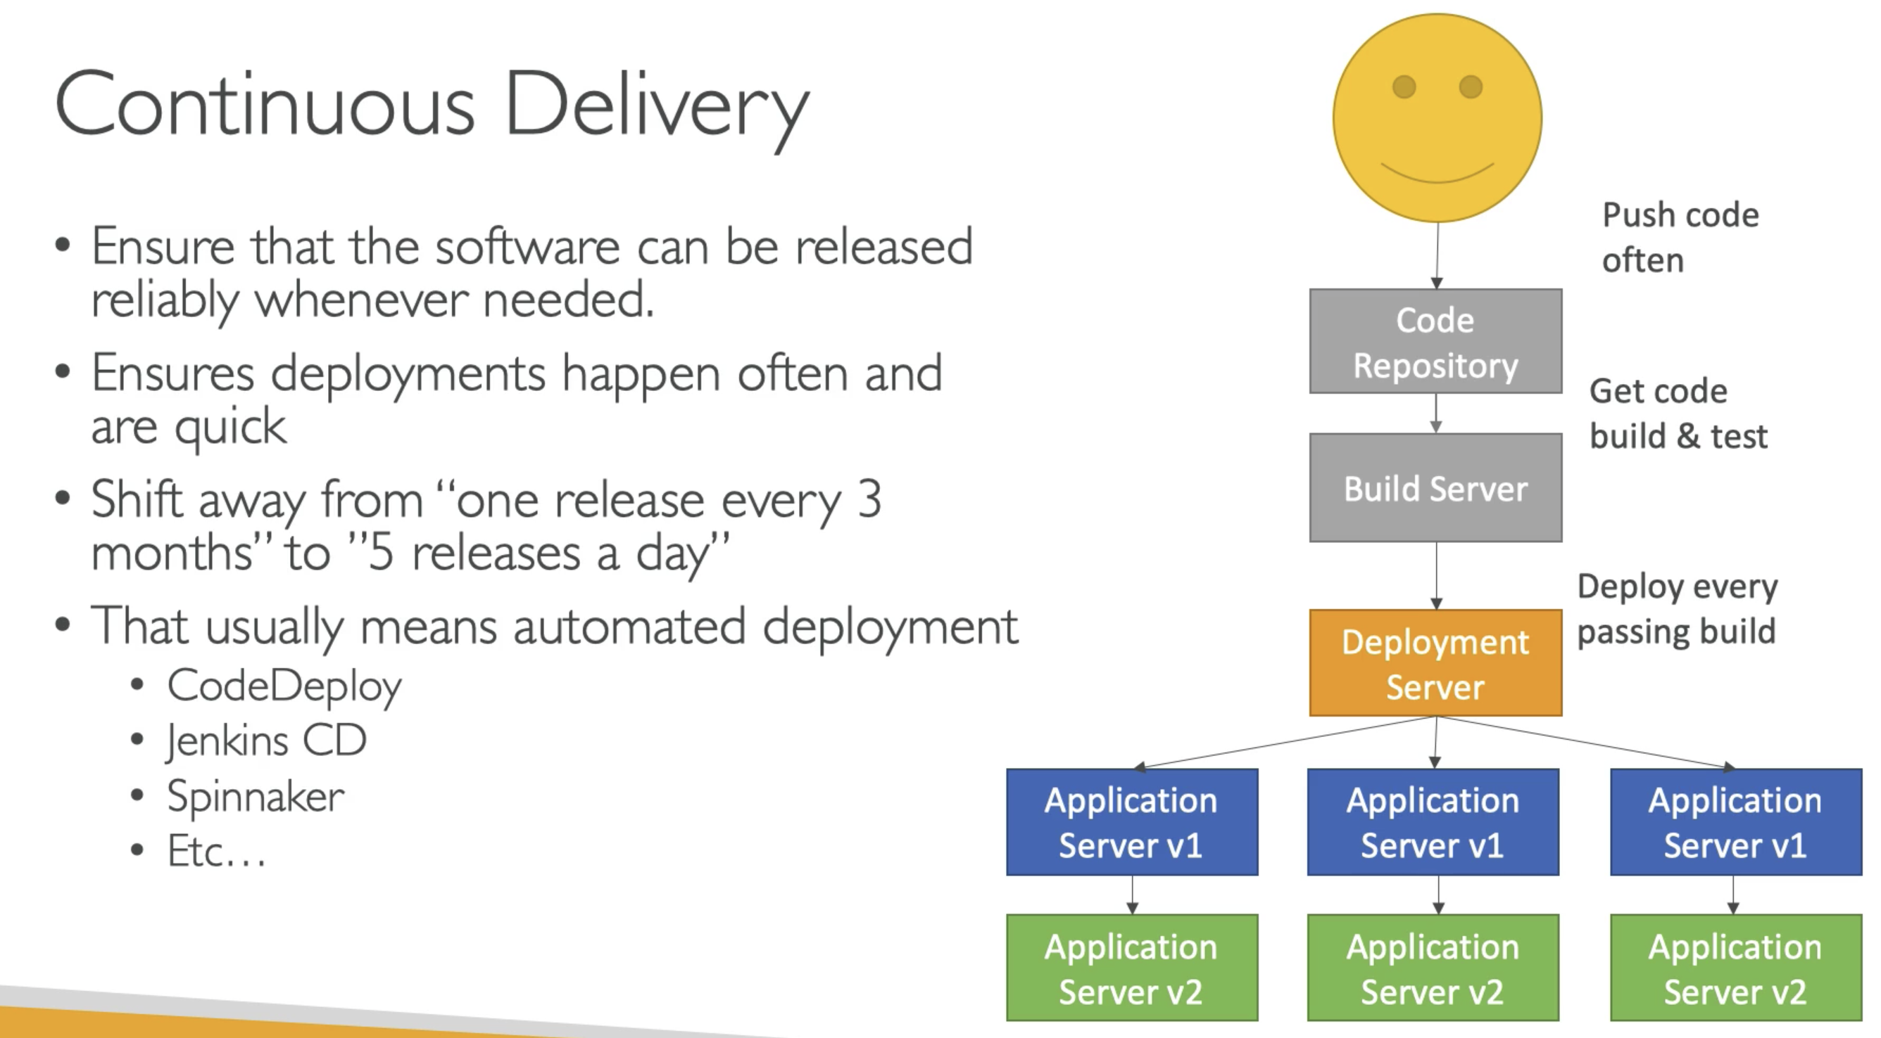

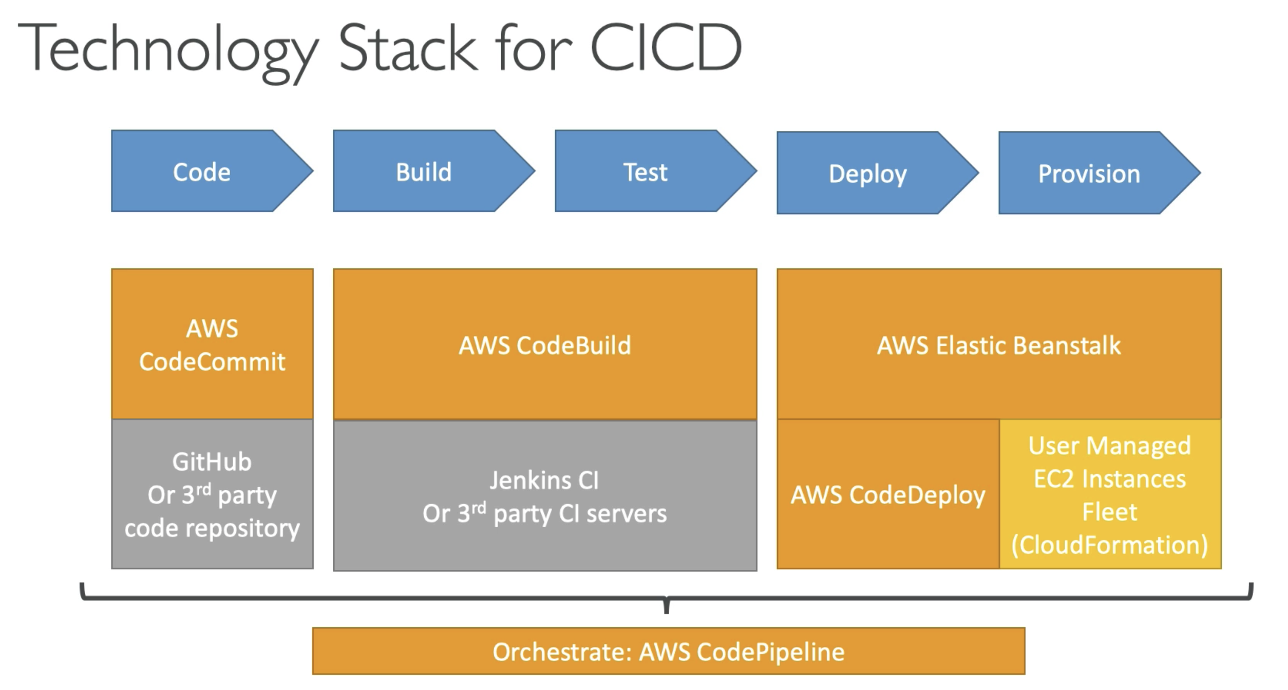

# 275. CloudFormation

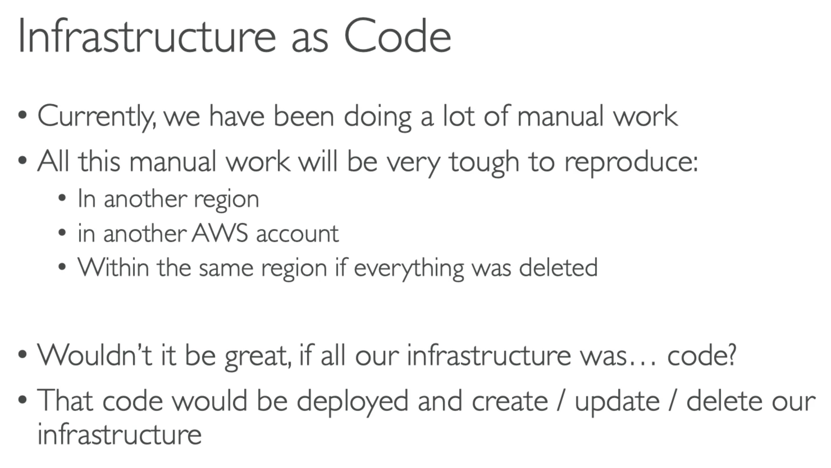

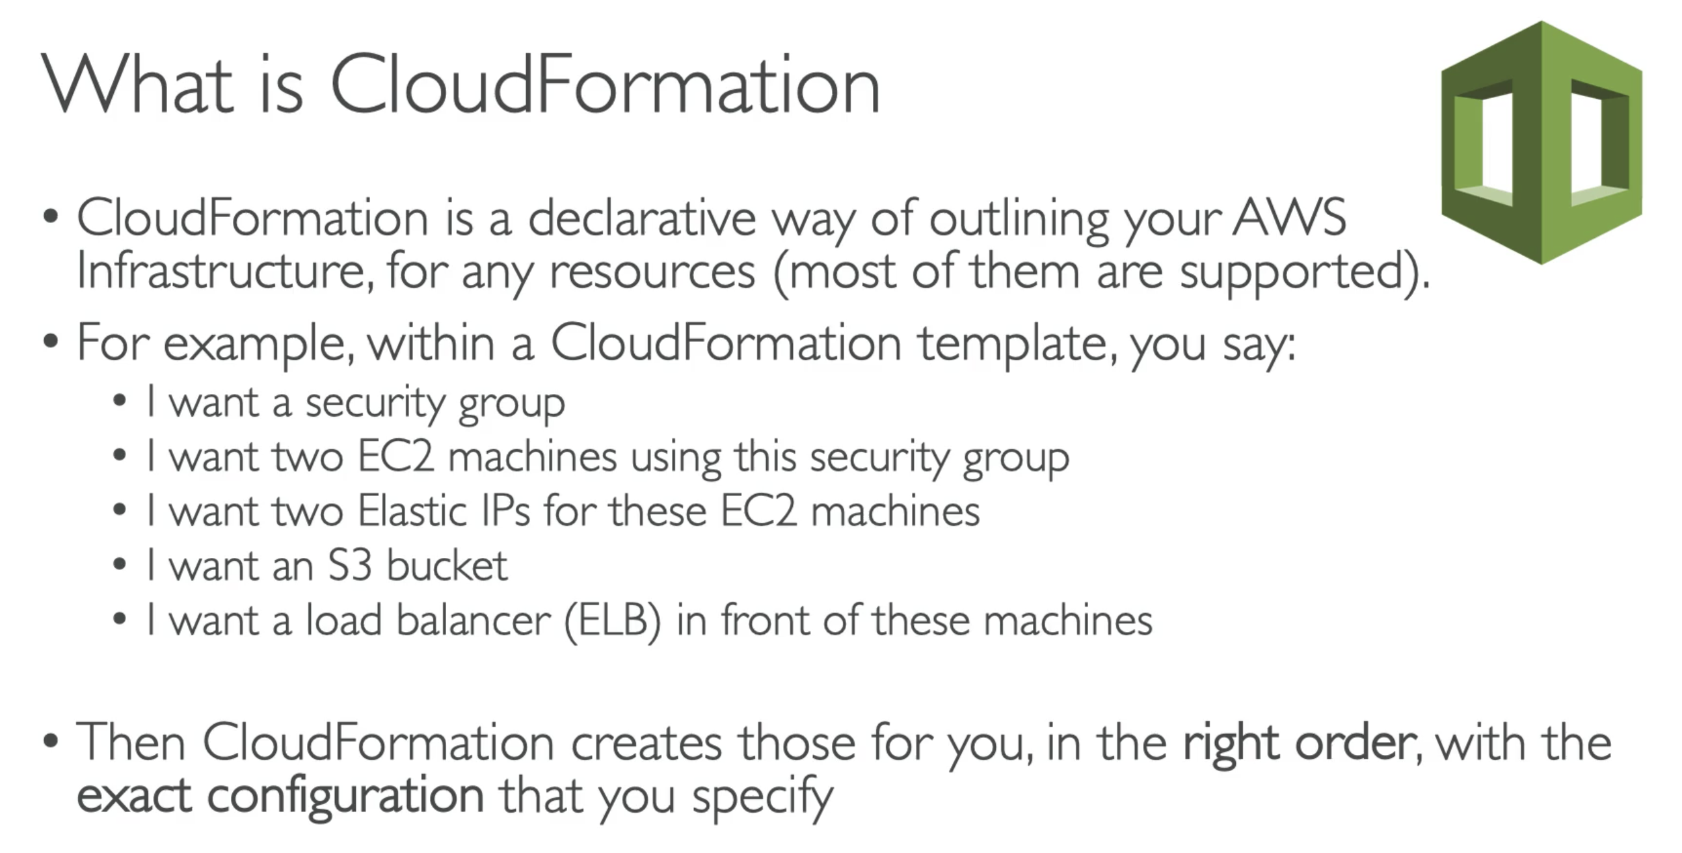

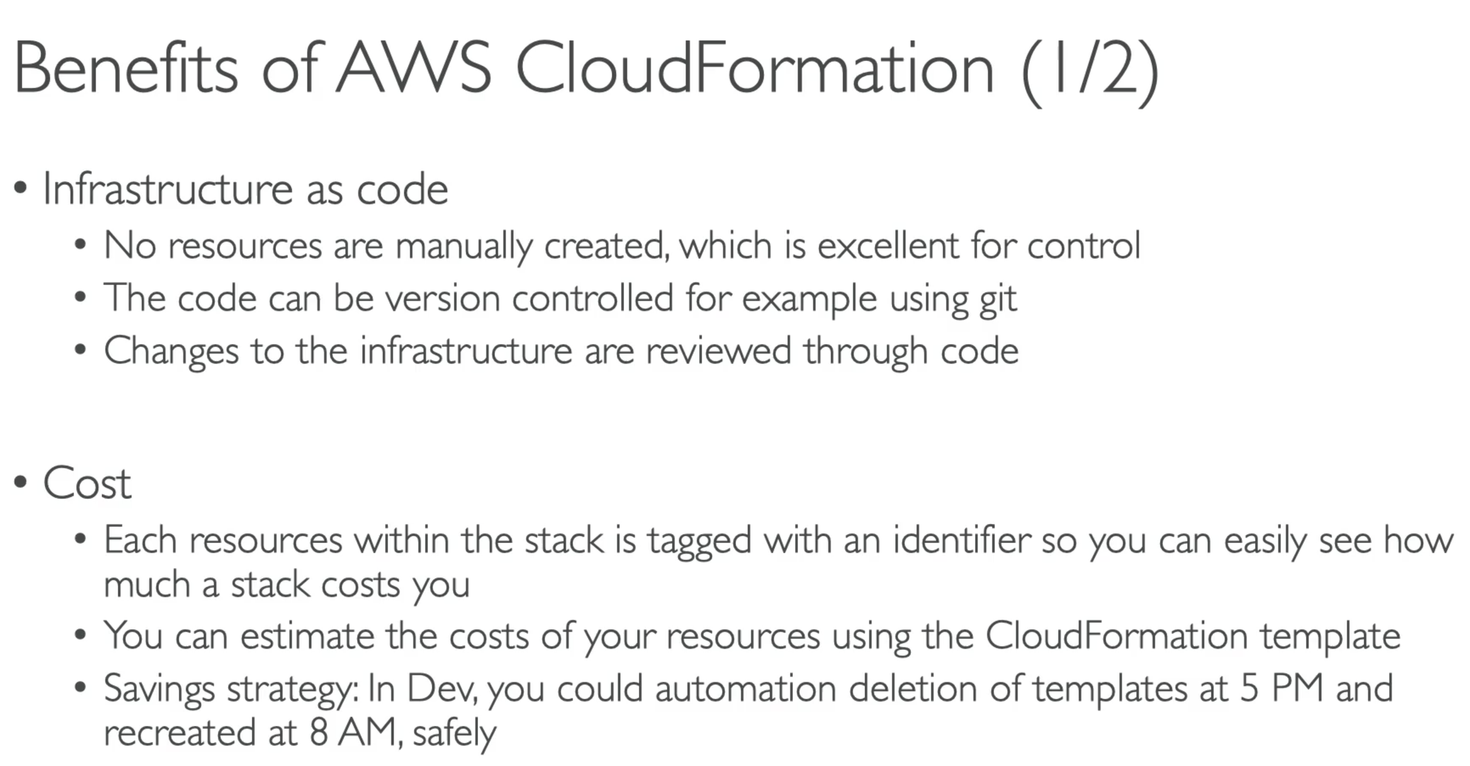

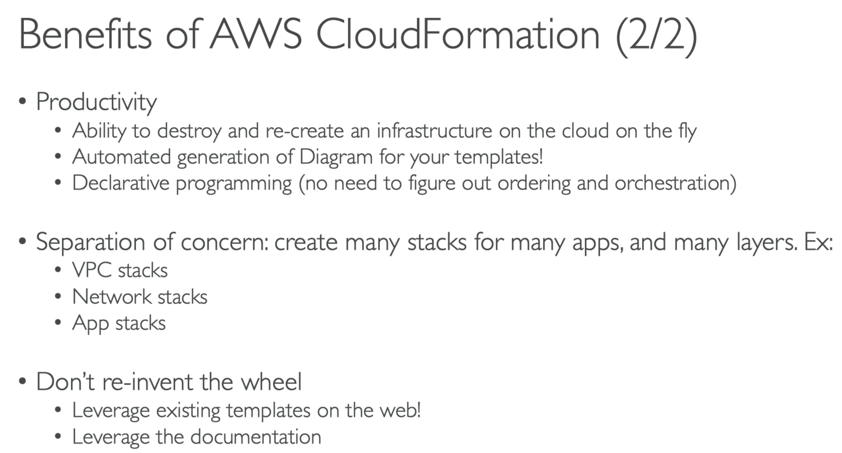

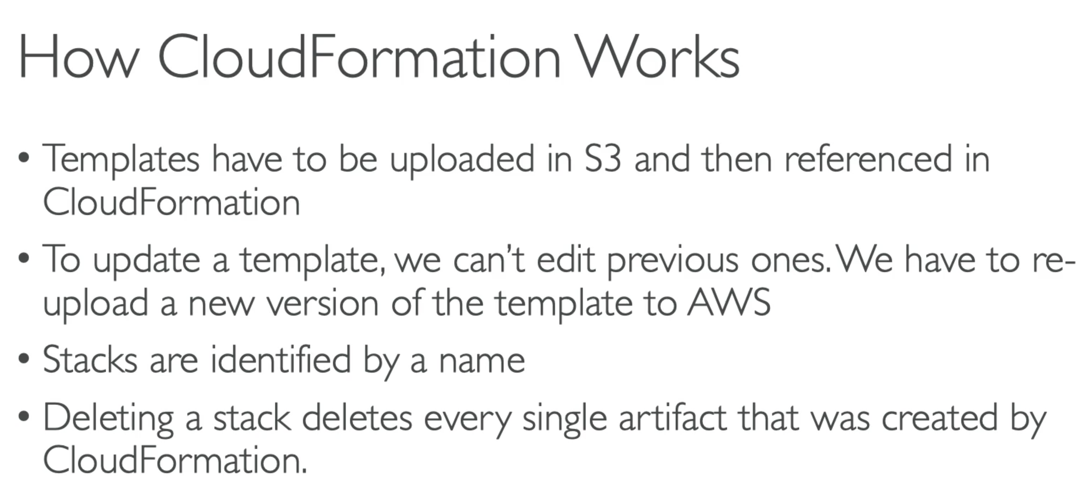

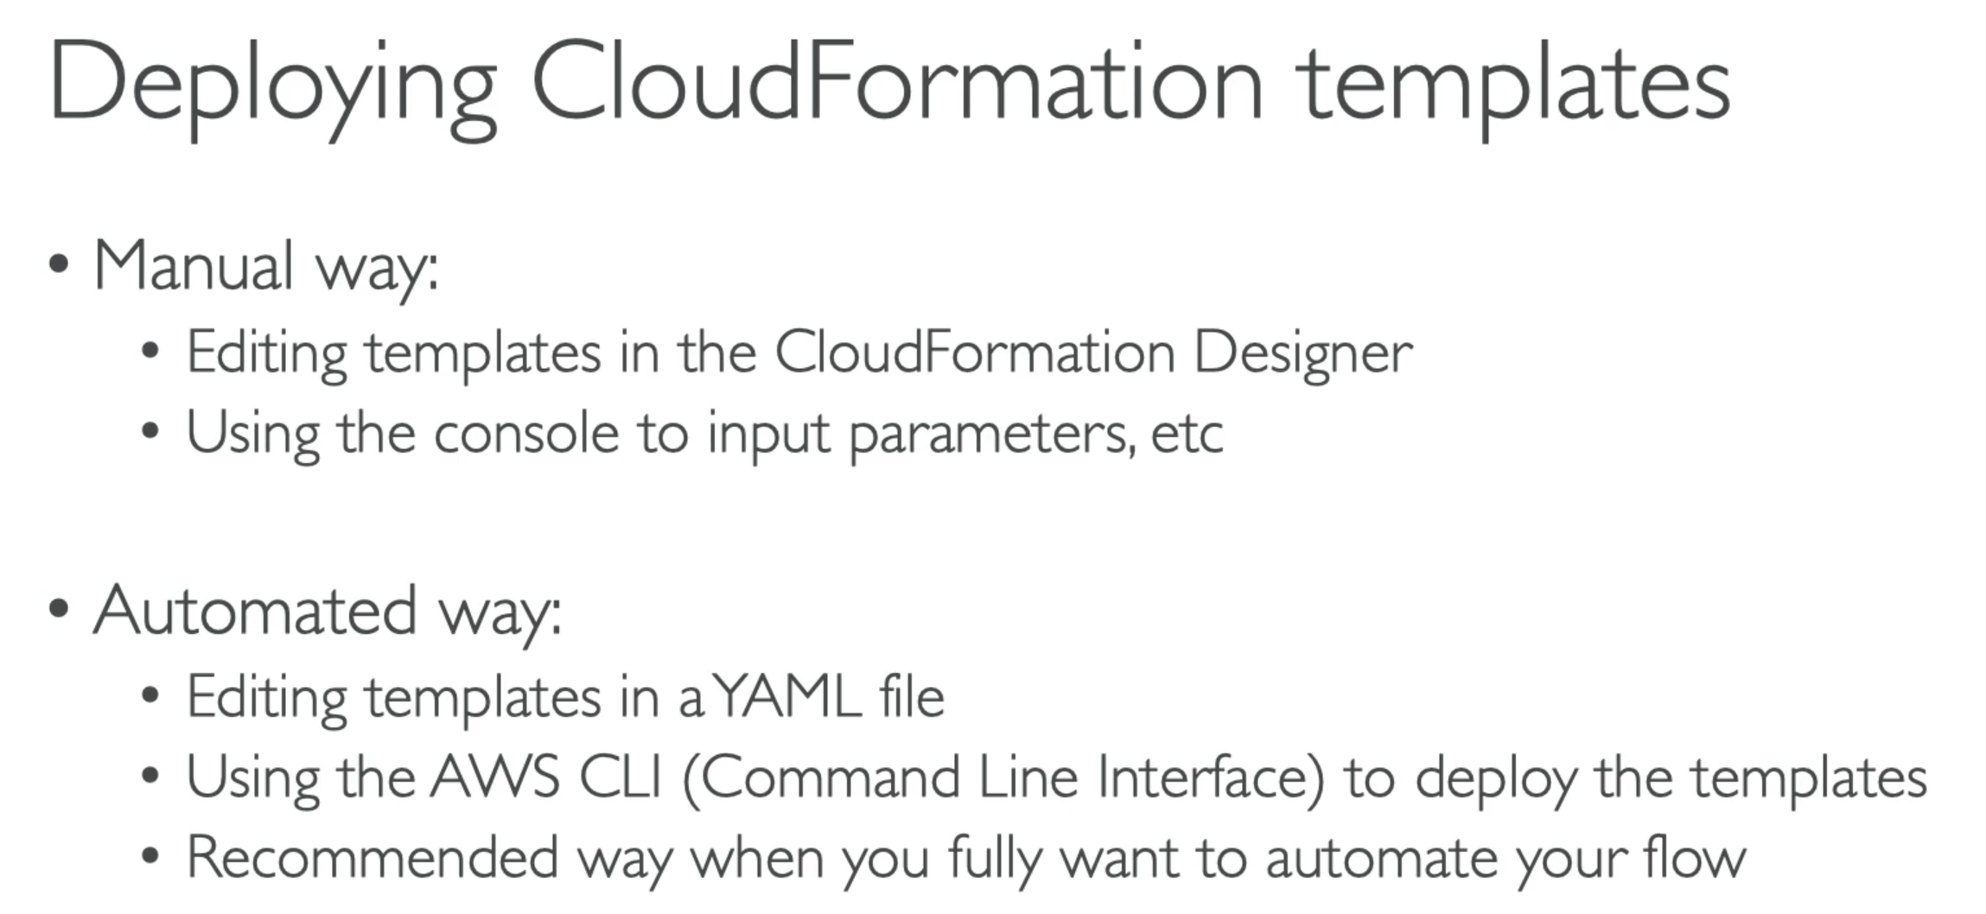

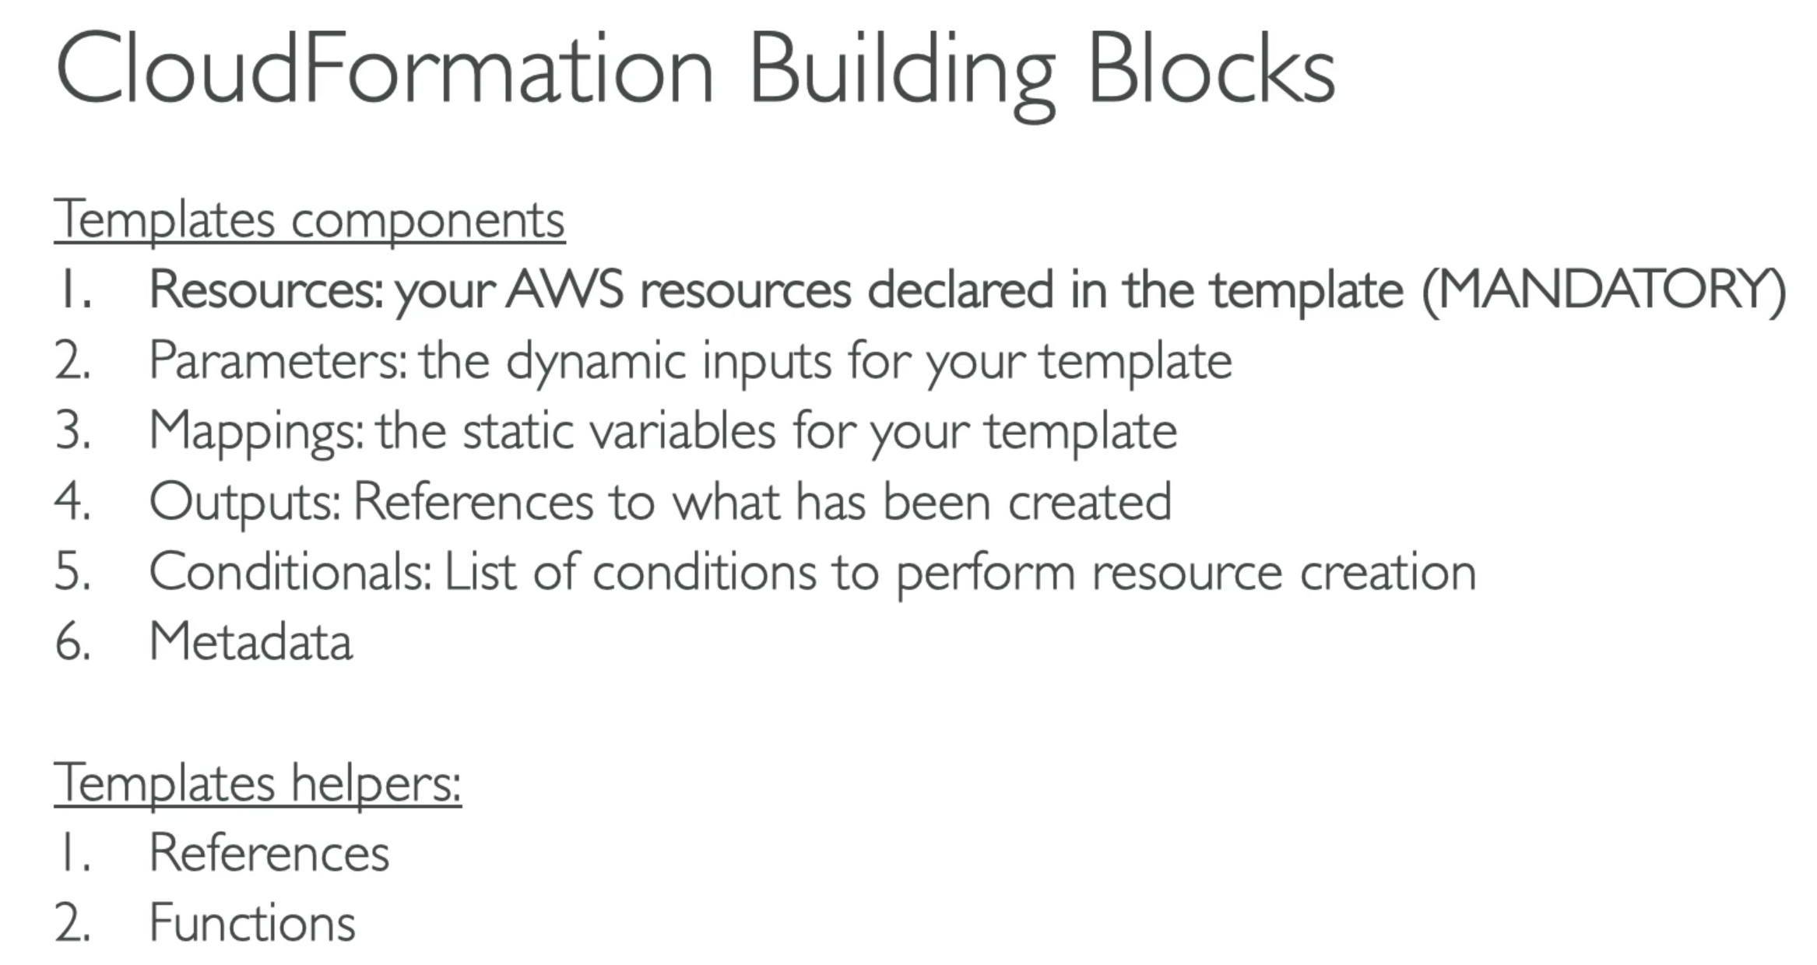

Note: Remember CloudFormation template has Resources, Parameters and Output … these are most important ones…

# 276. CloudFormation – Hands On

# 277. CloudFormation – Extras

## StackSets

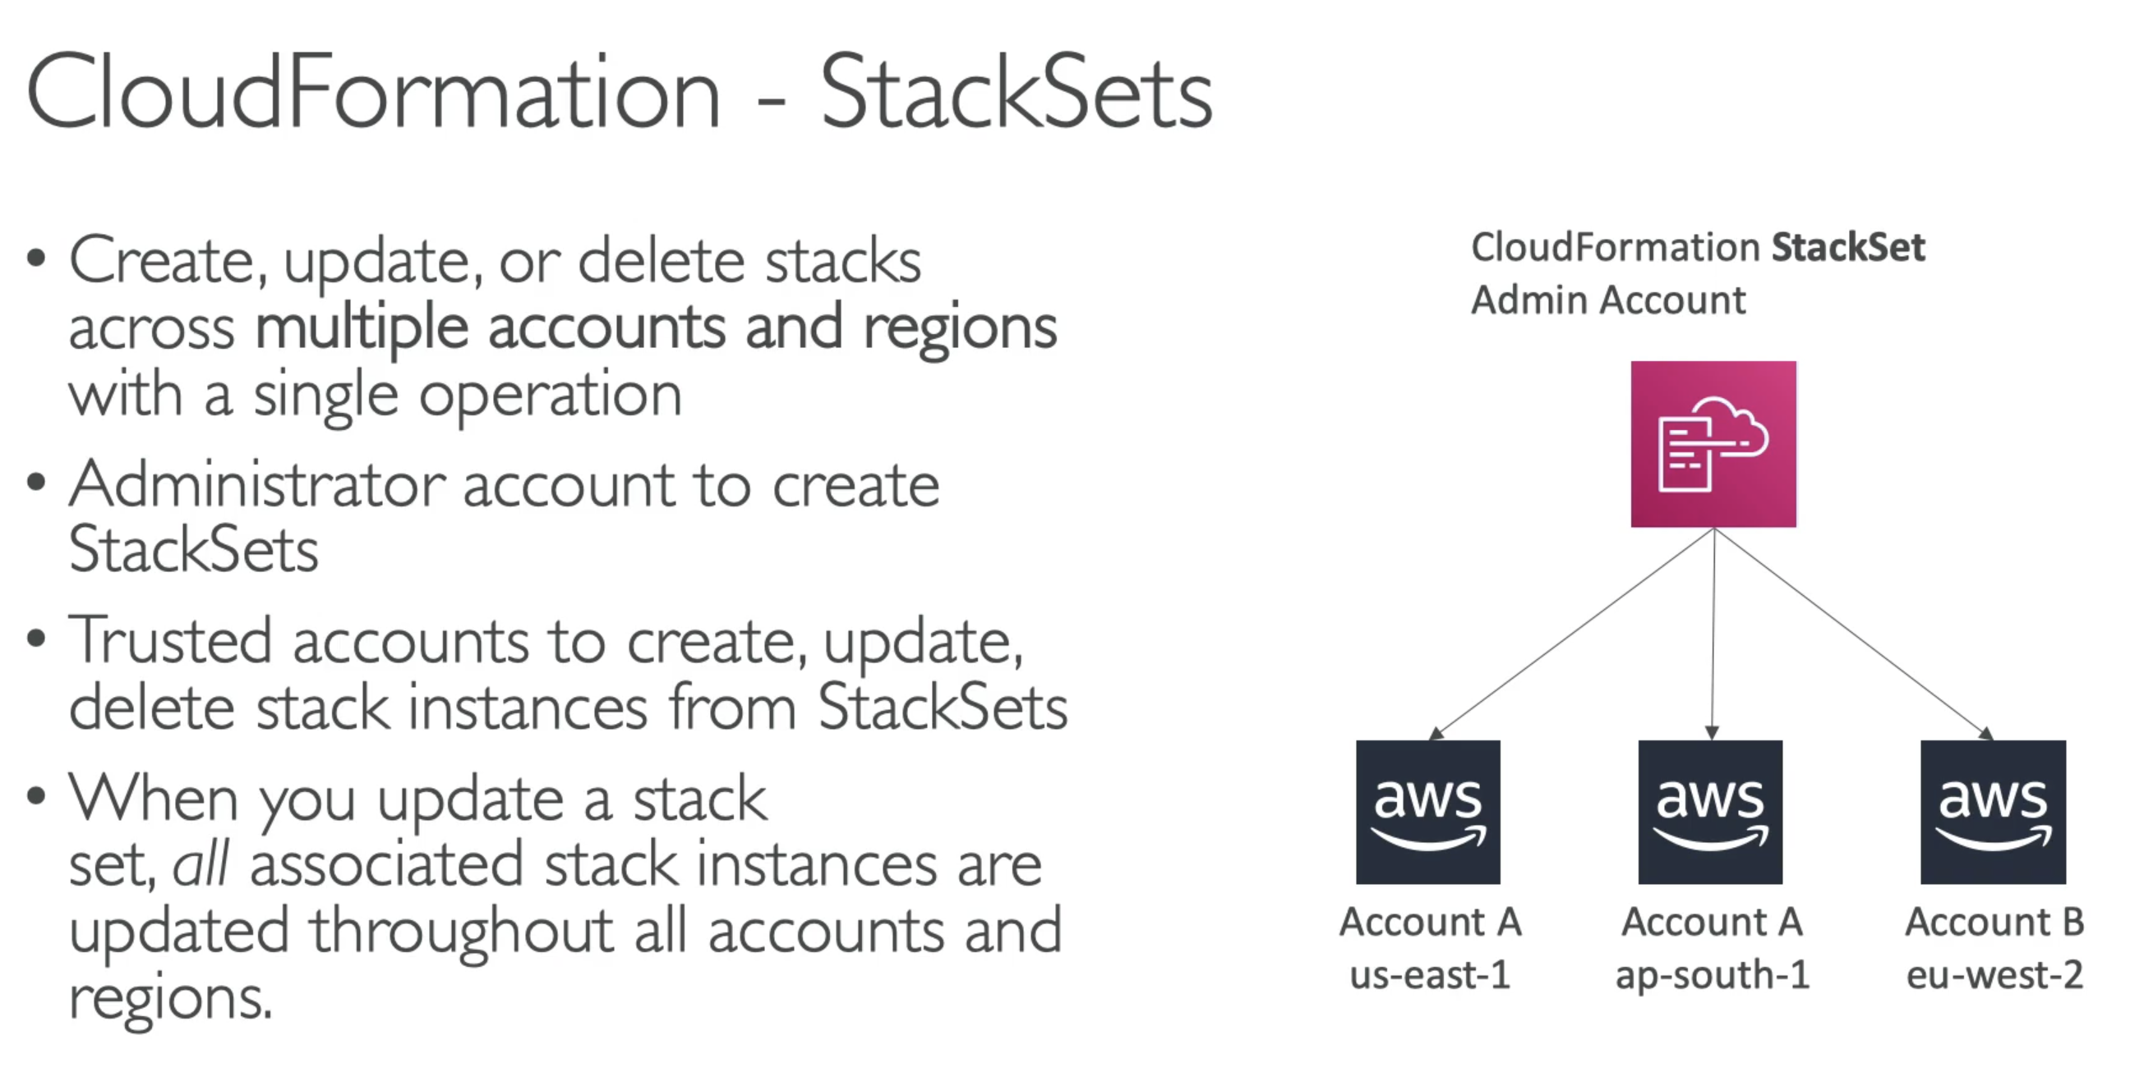

Note: Deploying a CloudFormation Stack globally or Cross-account …. Think of StackSets

# 278. ECS Introduction

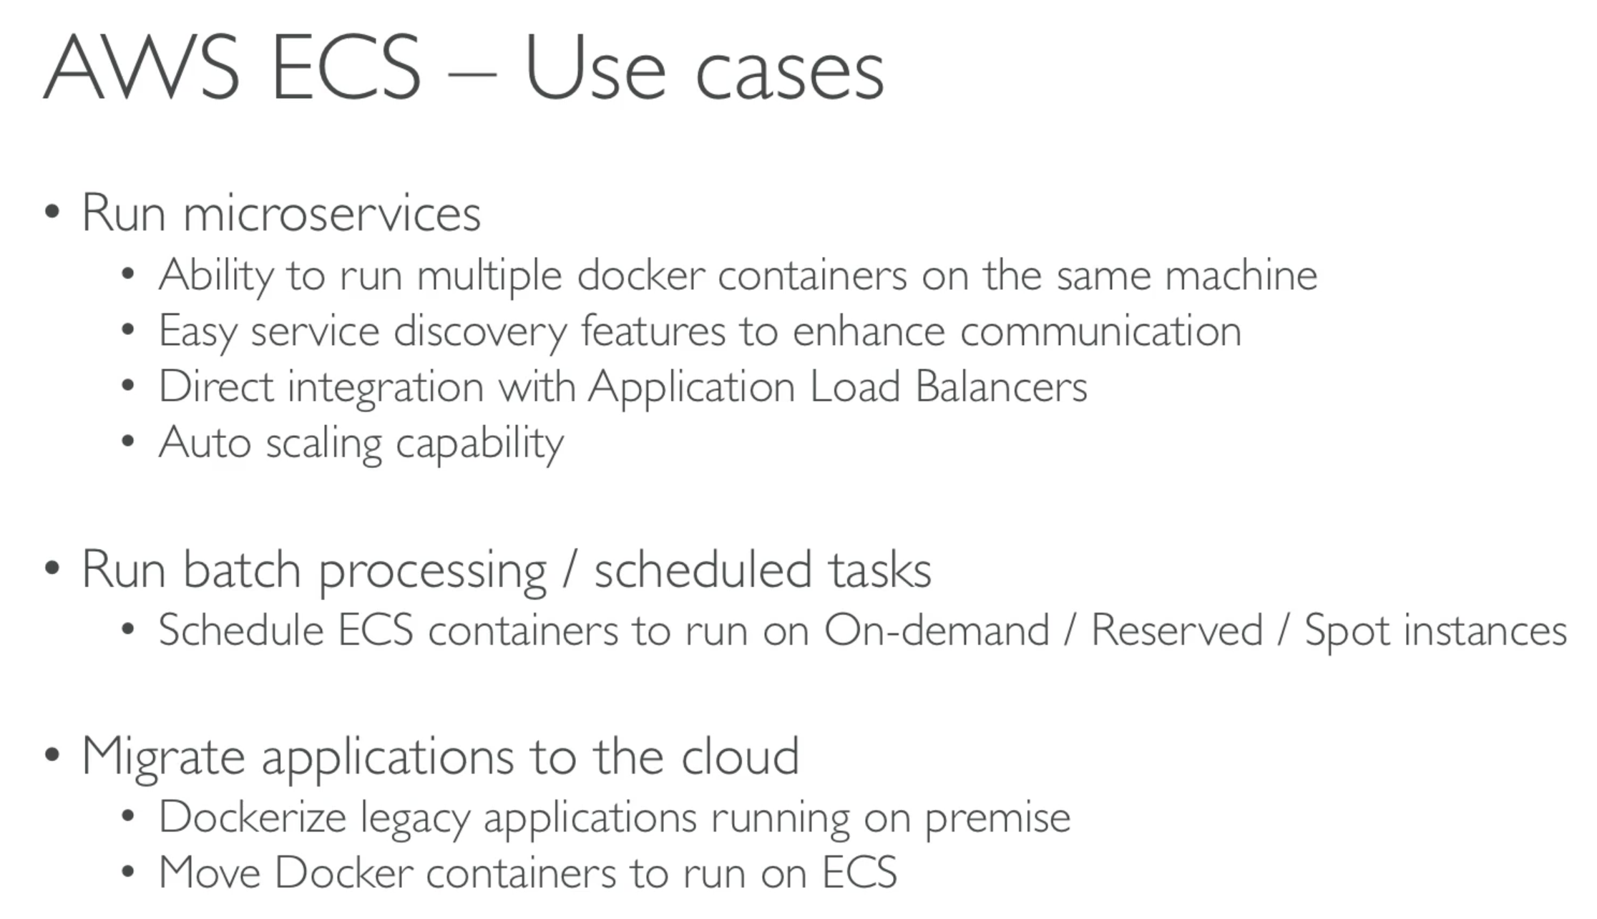

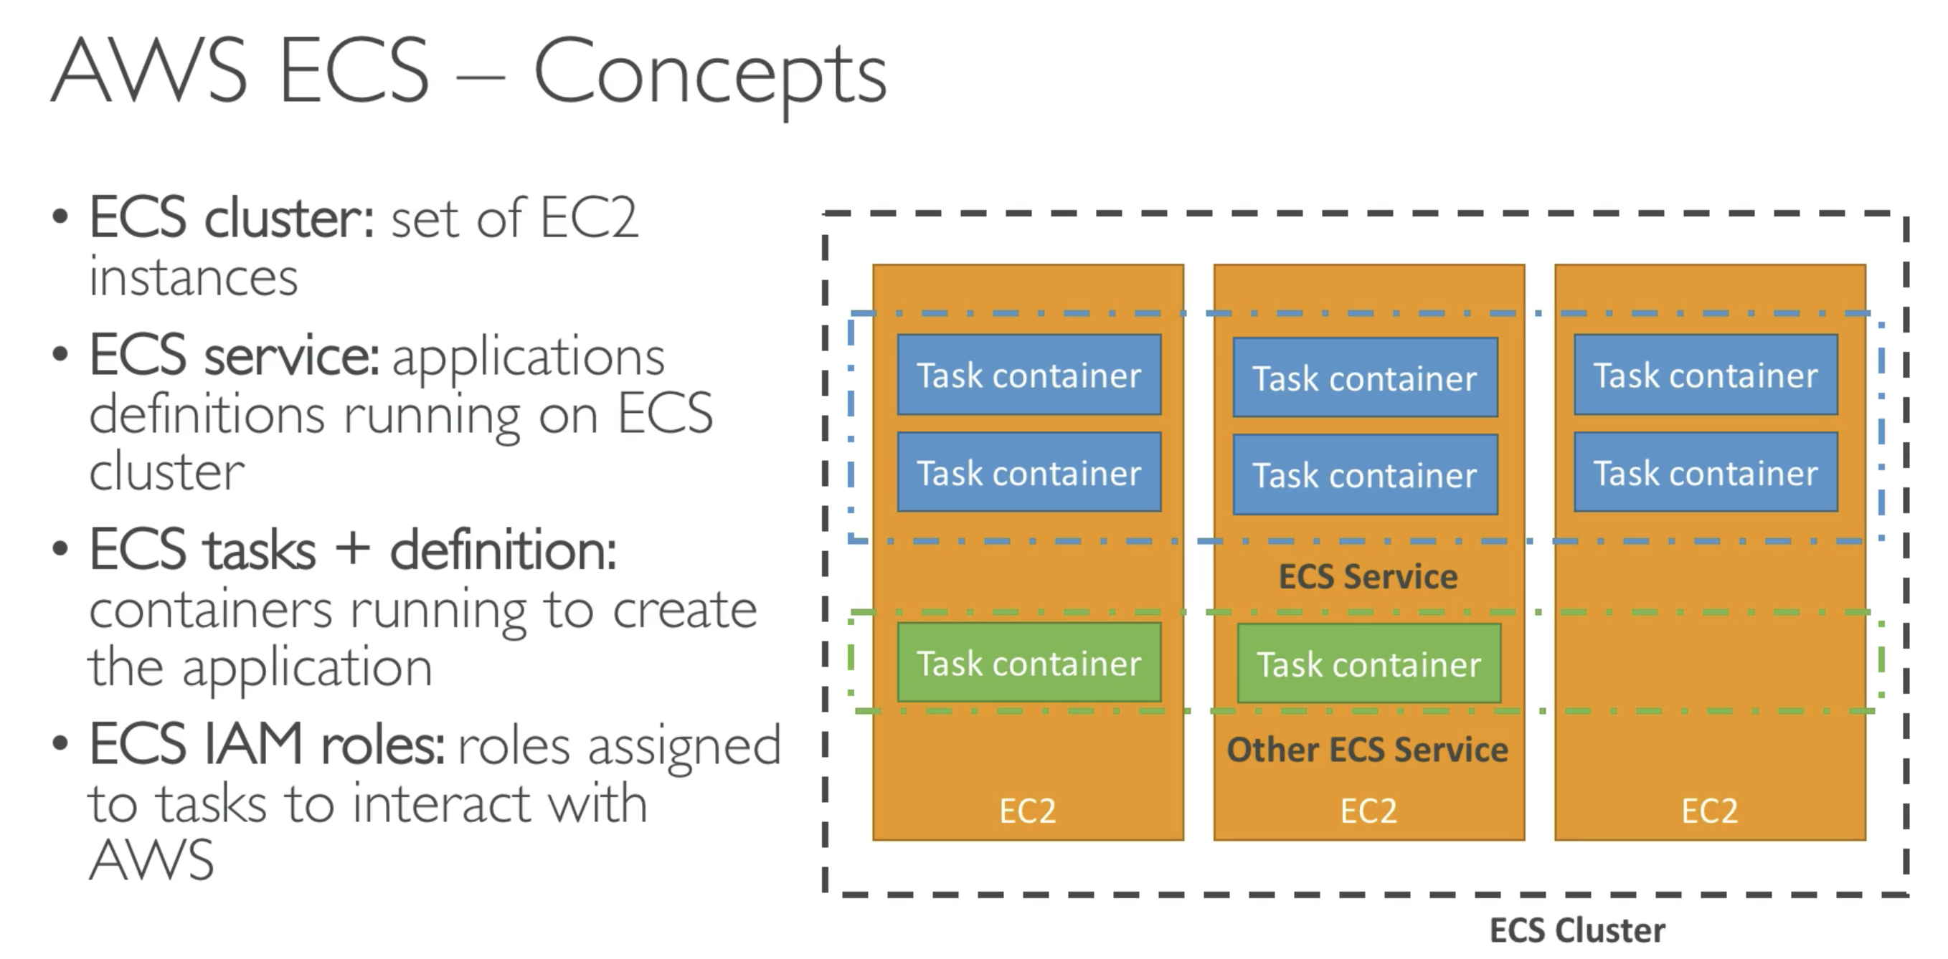

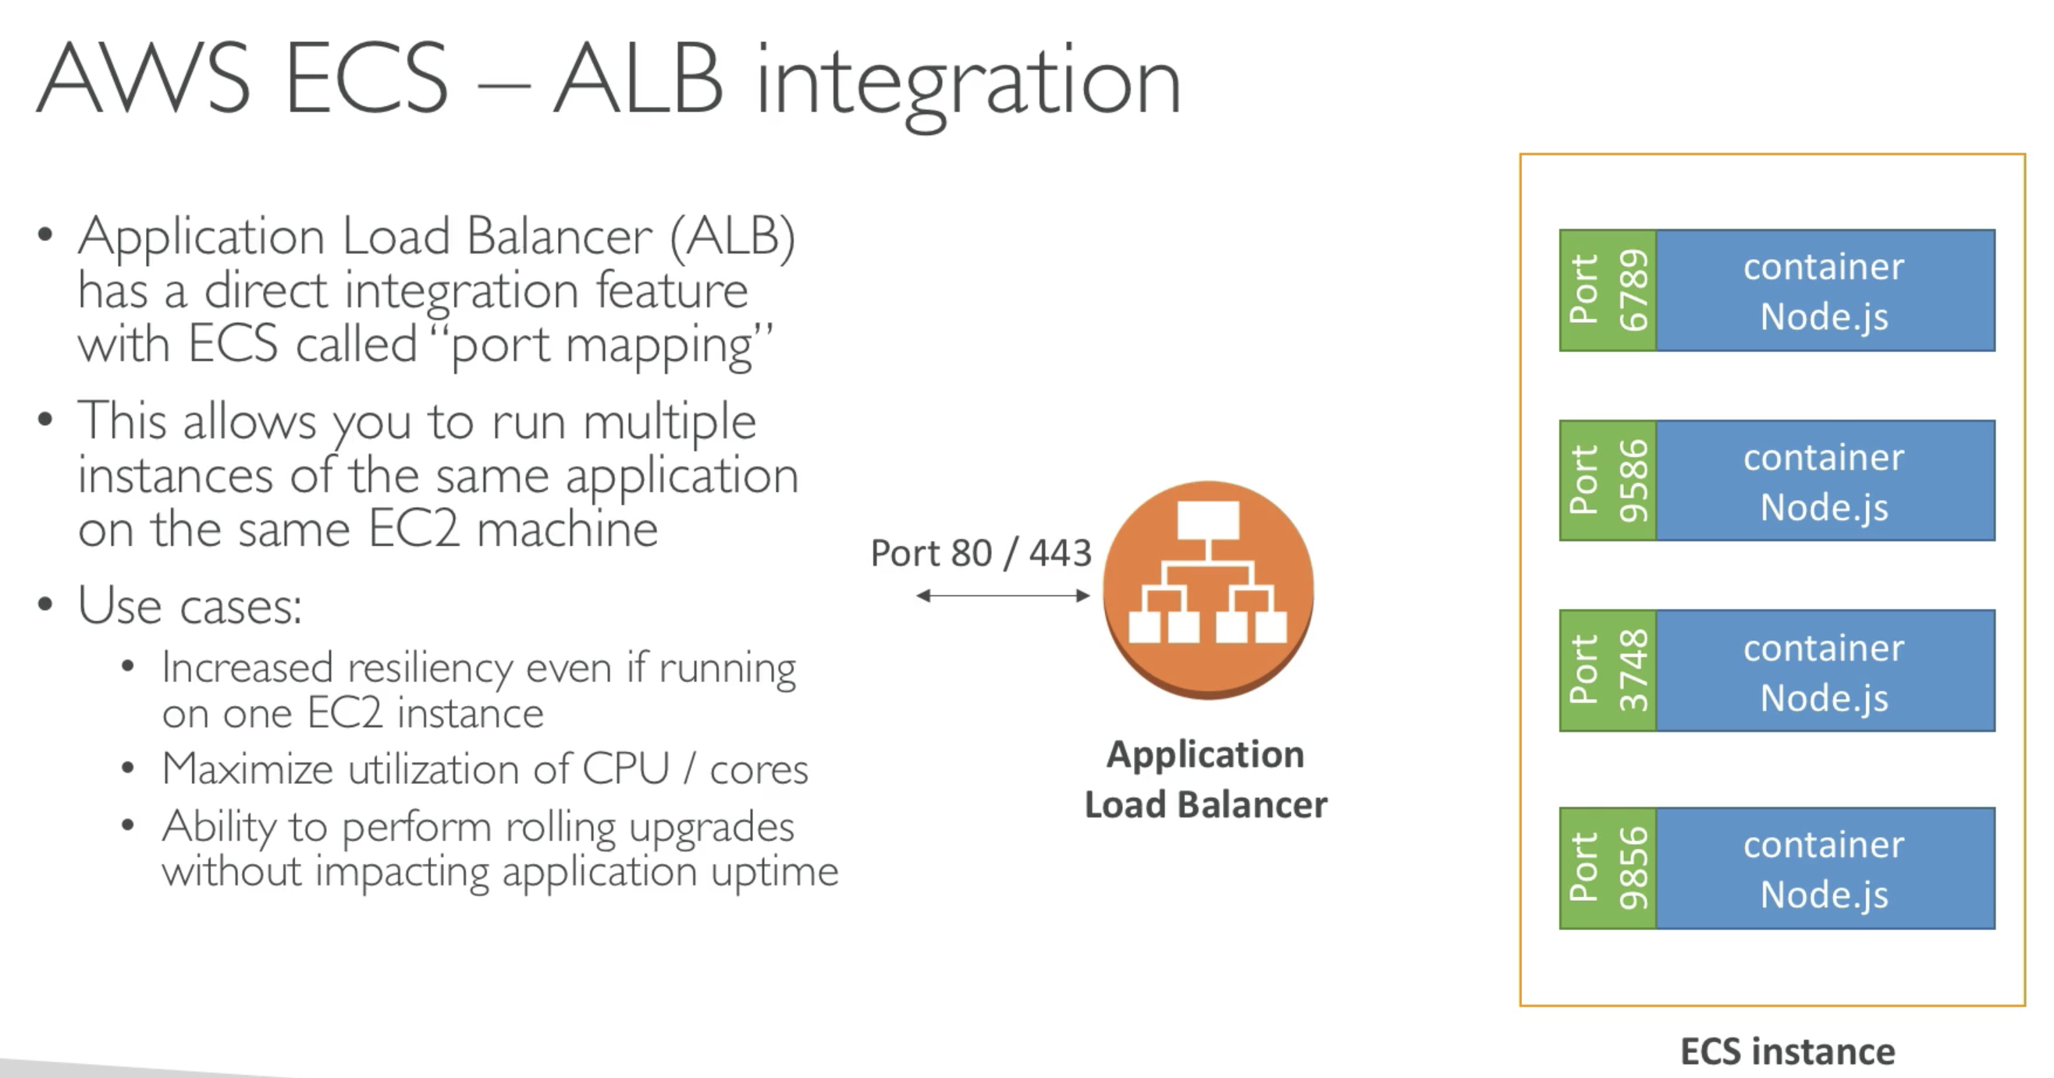

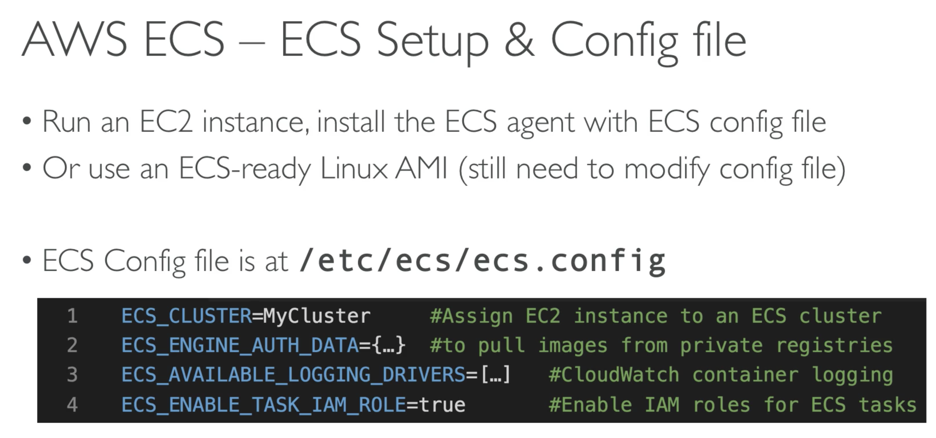

# 281. Step Functions and SWF

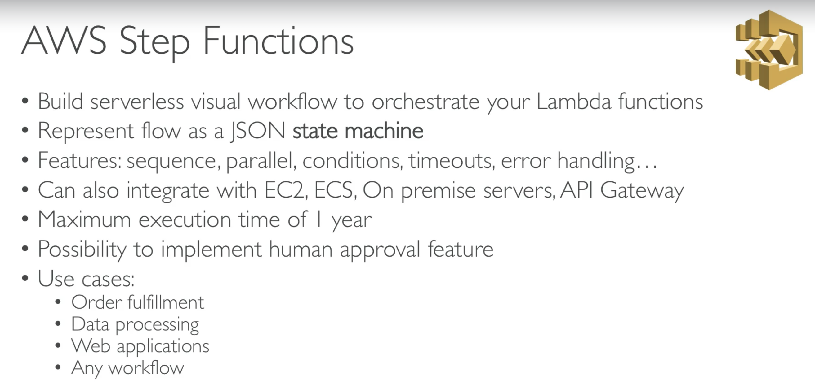

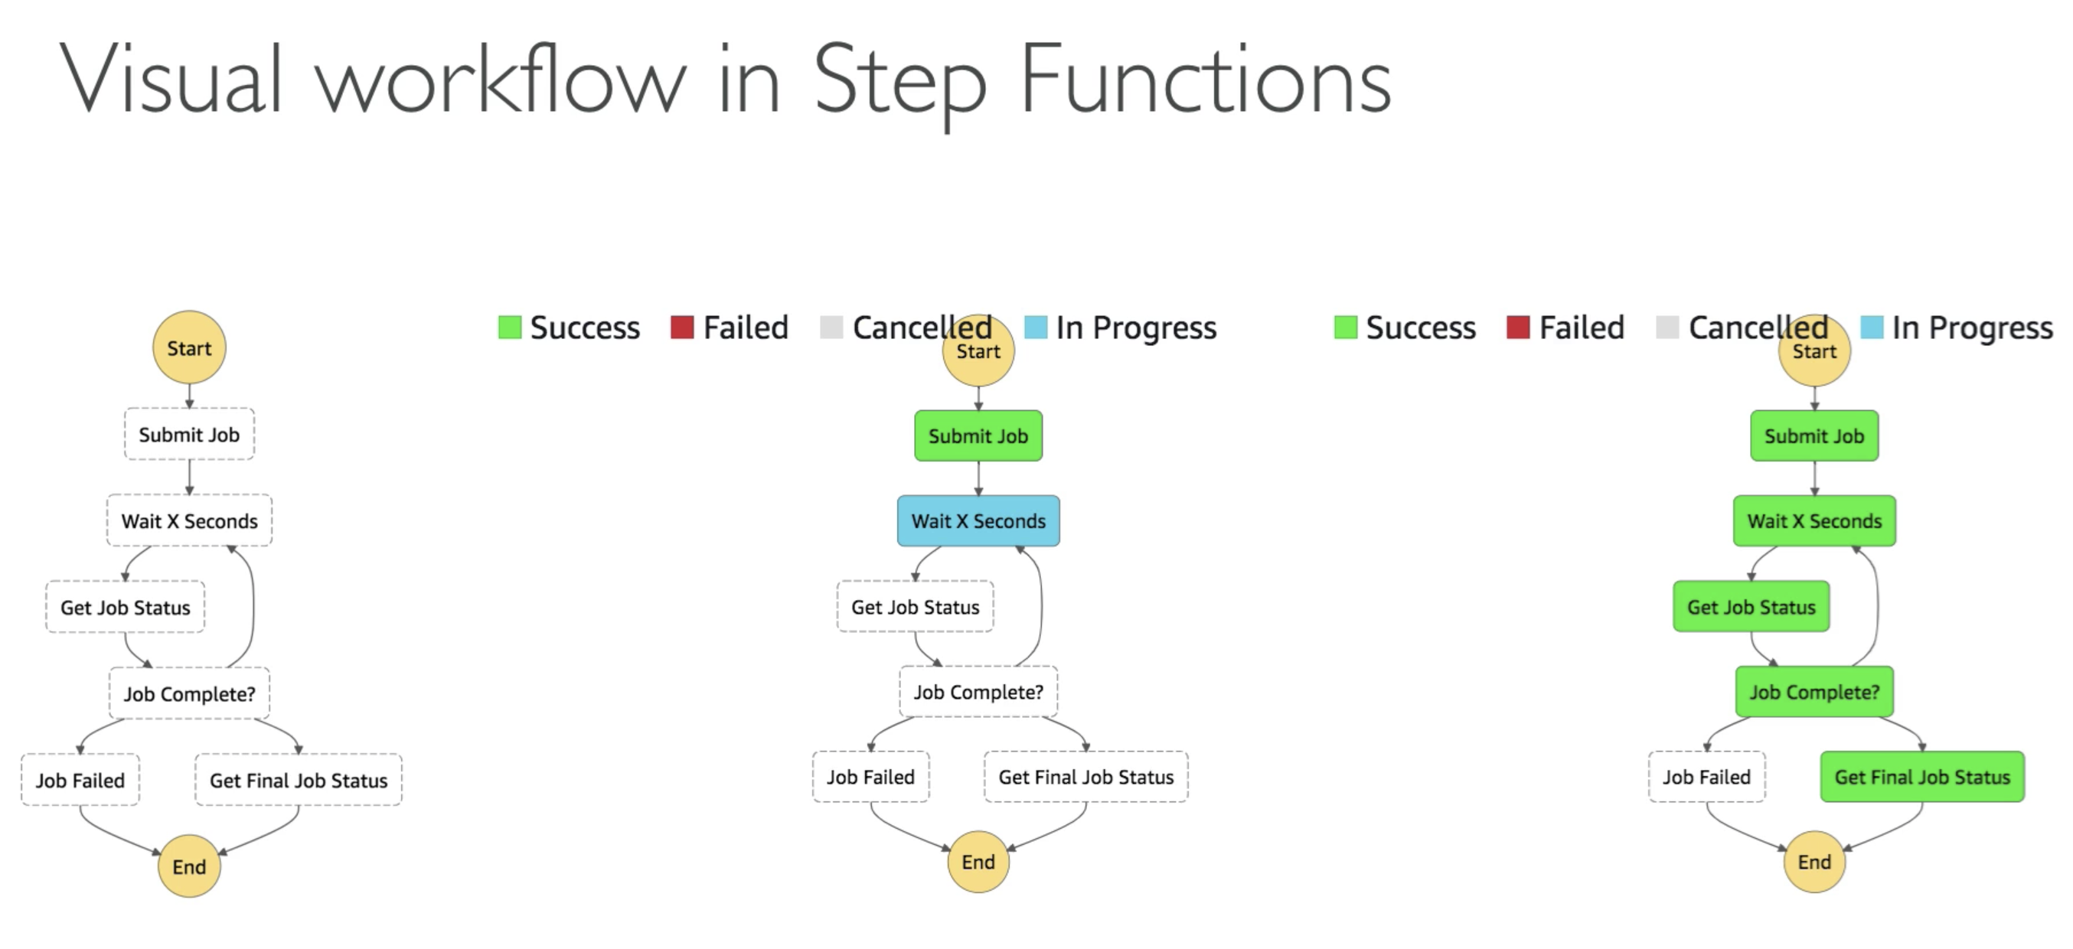

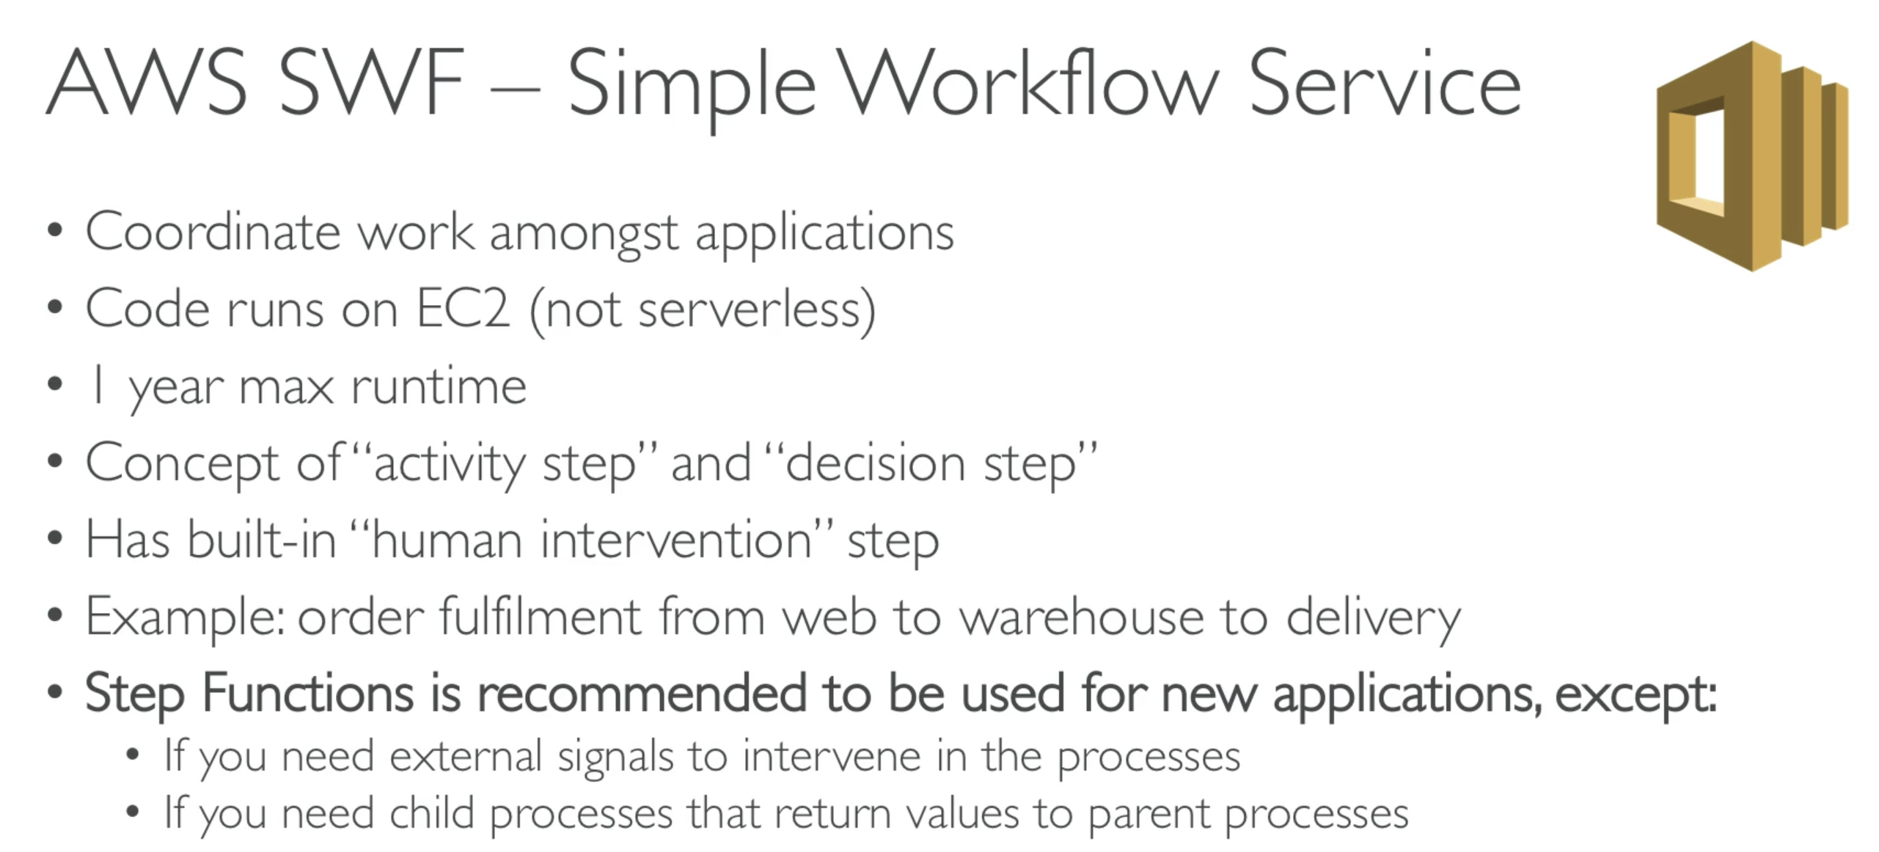

# 282. EMR

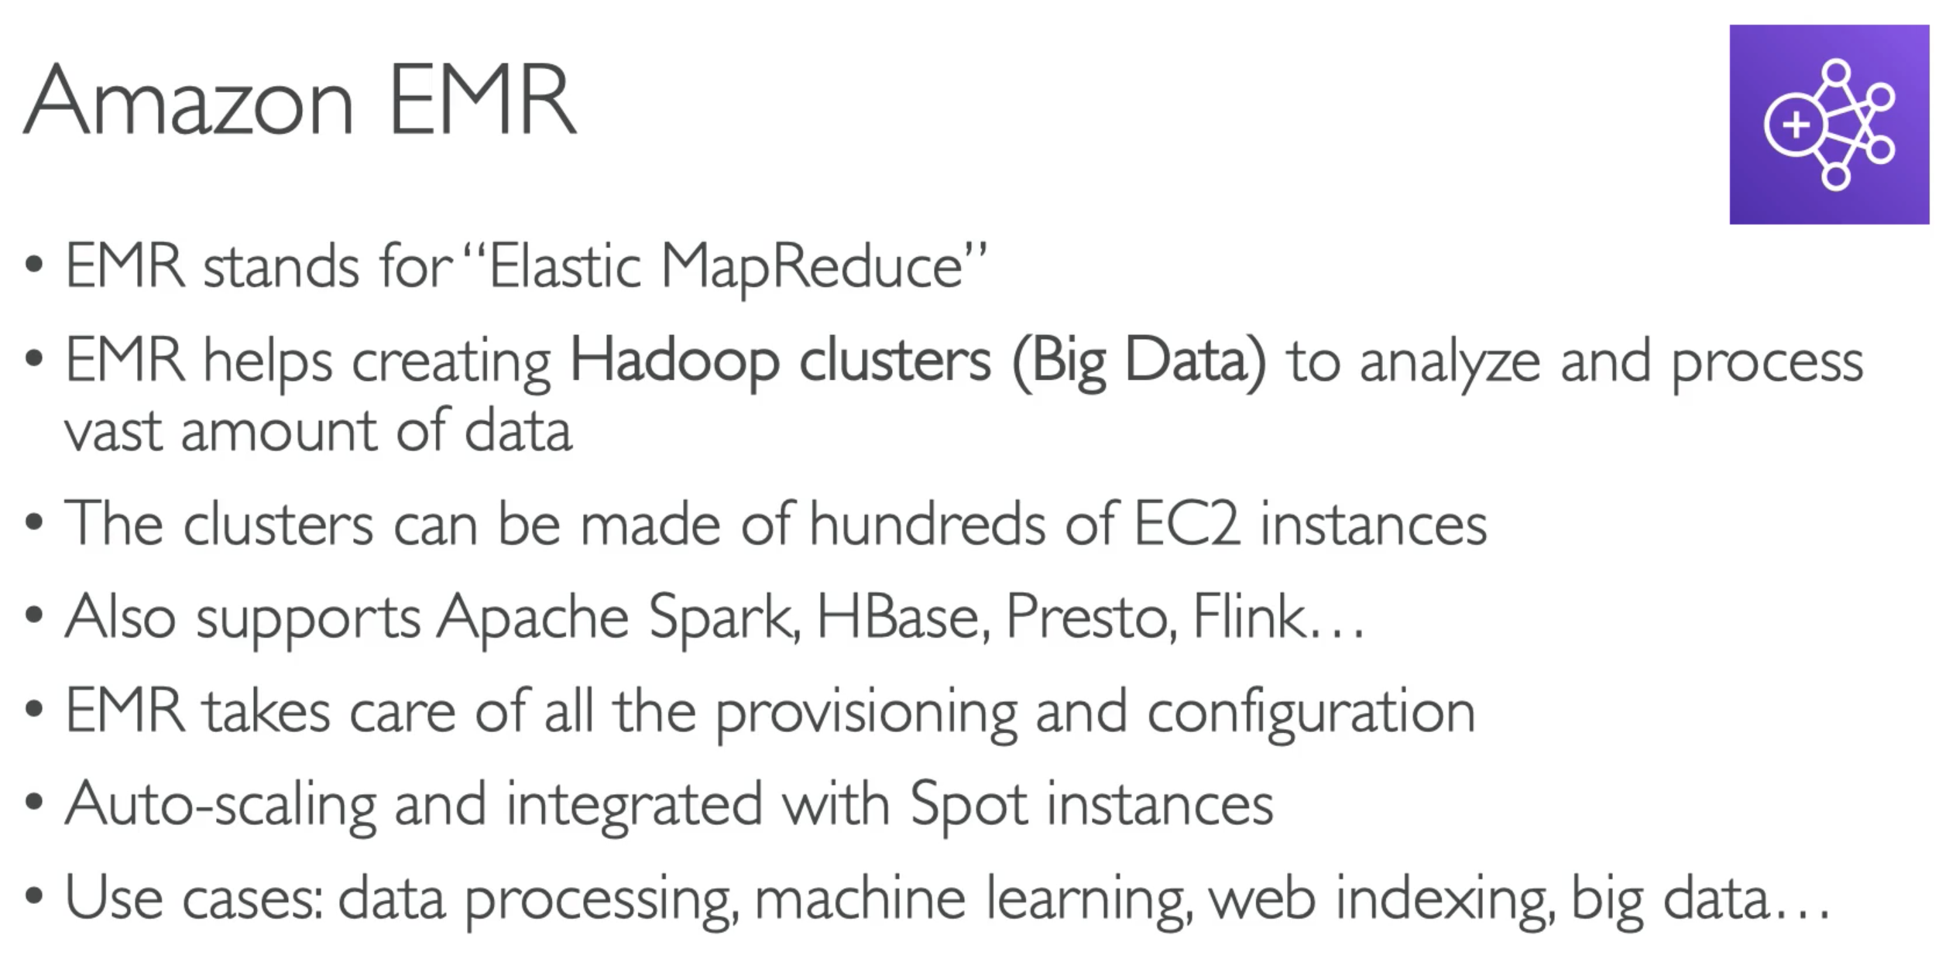

**ExamTip: If you see keywords like – Hadoop, Spark, Big Data processing 🡪 think of EMR

# 283. AWS Glue

# 284. OpsWorks

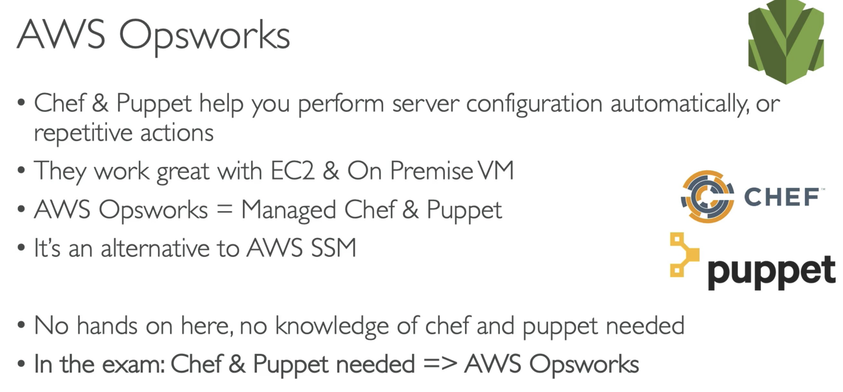

# 285. ElasticTranscoder

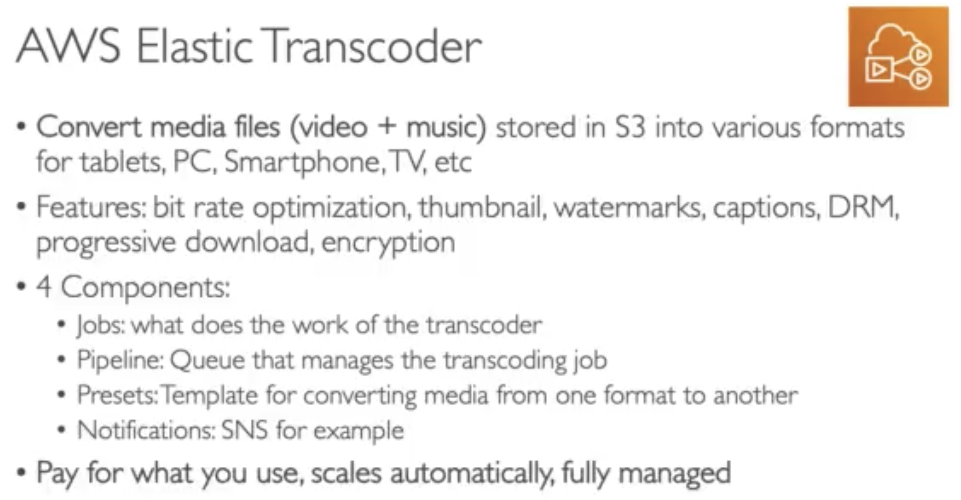

** ElasticTranscoder 🡺 Media Transcoding

# 286. AWS Workspaces

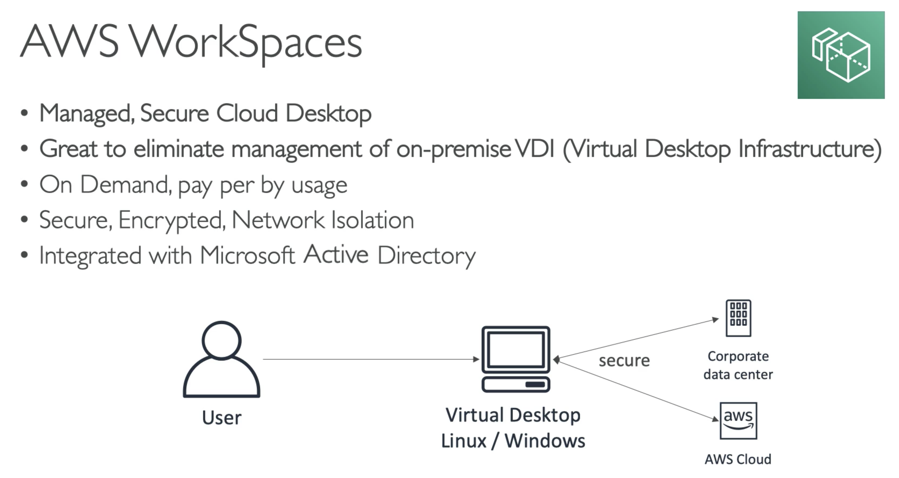

ExamTip: When you see the word – VDI; how do you replace your VDI infrastructure?

Ans: Workspaces

# 287. AppSync

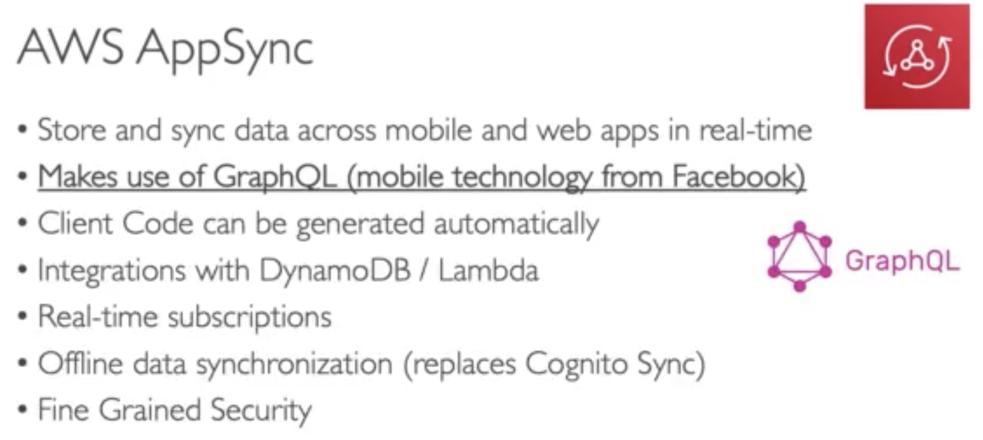

ExamTip: When you see use cases – synchronising data between mobile and web apps in real time… it is either CognitoSync or AppSync.

And then if you see GraphQL 🡪 it is AppSync

# 324. Cost Explorer

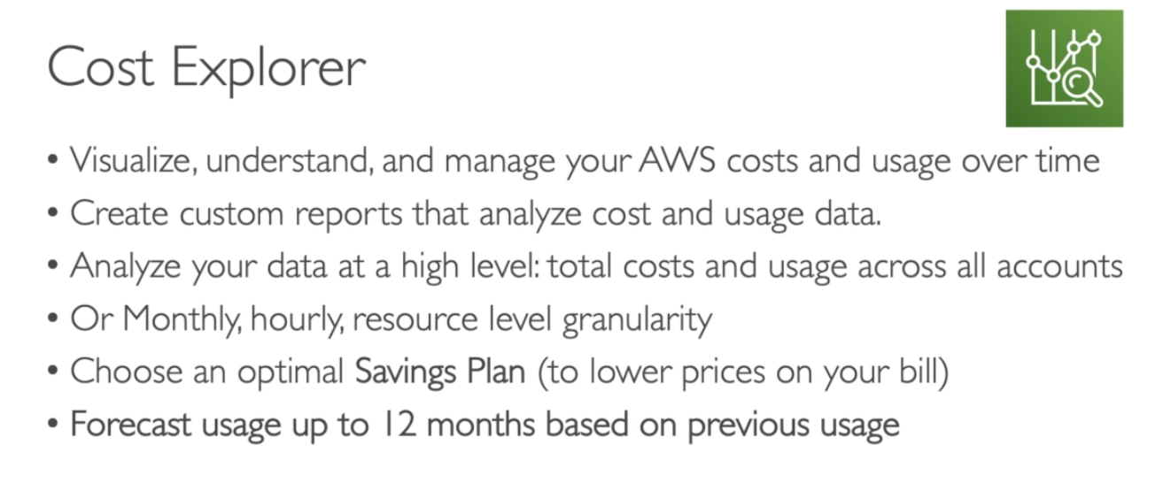

# 288. Other Services: Cheat Sheet

Here's a quick cheat-sheet to remember all these services:

1. **CodeCommit:** service where you can store your code. Similar service is GitHub
2. **CodeBuild:** build and testing service in your CICD pipelines. This is an alternative to Jenkils
3. **CodeDeploy:** deploy the packaged code onto EC2 and AWS Lambda
4. **CodePipeline:** orchestrate the actions of your CICD pipelines (build stages, manual approvals, many deploys, etc)
5. **CloudFormation:** Infrastructure as Code for AWS. Declarative way to manage, create and update resources.
6. **ECS (Elastic Container Service):** Docker container management system on AWS. Helps with creating micro-services.
7. **ECR (Elastic Container Registry):** Docker images repository on AWS. Docker Images can be pushed and pulled from there
8. **Step Functions:** Orchestrate / Coordinate Lambda functions and ECS containers into a workflow
9. **SWF (Simple Workflow Service):** Old way of orchestrating a big workflow.
10. **EMR (Elastic Map Reduce):** Big Data / Hadoop / Spark clusters on AWS, deployed on EC2 for you
11. **Glue:** ETL (Extract Transform Load) service on AWS
12. **OpsWorks:** managed Chef & Puppet on AWS
13. **ElasticTranscoder:** managed media (video, music) converter service into various optimized formats
14. **Organizations:** hierarchy and centralized management of multiple AWS accounts
15. **Workspaces:** Virtual Desktop on Demand in the Cloud. Replaces traditional on-premise VDI infrastructure
16. **AppSync:** GraphQL as a service on AWS
17. **SSO (Single Sign On):** One login managed by AWS to log in to various business SAML 2.0-compatible applications (office 365 etc)
18. **AWS SAM**

AWS Serverless Application Model (AWS SAM) is an extension of AWS CloudFormation that is used to package, test, and deploy serverless applications.

# Quiz

